|  |  |  |  |
| --- | --- | --- | --- |
| Input | Expected | Actual | Pass/Fail |
| Checking/100/deposit | Success/balance 100 | Success/balance 100 | Pass |
| Savings/100/deposit | Success/balance 100 | Success/balance 100 | Pass |
| Checking/20/withdraw | Success/balance 80 | Success/balance 80 | Pass |
| Savings/20/withdraw | Success/balance 80 | Success/balance 80 | Pass |
| Checking/20/withdraw | Success/balance 60 | Success/balance 60 | Pass |
| Savings/20/withdraw | Success/balance 60 | Success/balance 60 | Pass |
| Checking/20/withdraw | Success/balance 38.50 | Success/balance 38.50 | Pass |
| Savings/20/withdraw | Success/balance 38.50 | Success/balance 38.50 | Pass |
| Checking/100/withdraw | Error/Insufficient Funds Window | Insufficient Funds Window | Pass |
| Savings/100/withdraw | Error/Insufficient Funds Window | Insufficient Funds Window | Pass |
| Checking/<Blank>  /withdraw | Error/You may only withdraw amounts in $20 increments window | You may only withdraw amounts in $20 increments window | Pass |
| Checking/a  /withdraw | Error/You may only withdraw amounts in $20 increments window | You may only withdraw amounts in $20 increments window | Pass |
| Checking/5  /withdraw | Error/You may only withdraw amounts in $20 increments window | You may only withdraw amounts in $20 increments window | Pass |
| Savings/<Blank>  /withdraw | Error/You may only withdraw amounts in $20 increments window | You may only withdraw amounts in $20 increments window | Pass |
| Savings/a  /withdraw | Error/You may only withdraw amounts in $20 increments window | You may only withdraw amounts in $20 increments window | Pass |
| Savings/5  /withdraw | Error/You may only withdraw amounts in $20 increments window | You may only withdraw amounts in $20 increments window | Pass |
| Savings/balance | Success/38.50 | Success/38.50 | Pass |
| Checking/balance | Success/38.50 | Success/38.50 | Pass |
| Checking/100/deposit | Success/balance 138.50 | Success/balance 138.50 | Pass |
| Savings/100/transfer | Success/balance 138.50 | Success/balance 138.50 | Pass |
| Checking/100/transfer | Success/balance 138.50 | Success/balance 138.50 | Pass |
| Checking/100/transfer | Error/insufficient funds | Error/insufficient funds | Pass |
| Savings/200/transfer | Error/insufficient funds | Error/insufficient funds | Pass |

Table of Tested inputs for ATM.Java

Screenshots of compiling and testing inputs:

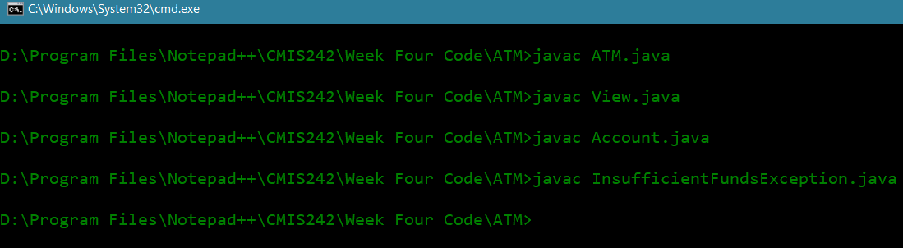

Compiled files

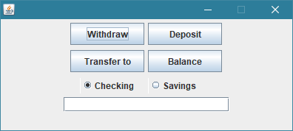

Startup

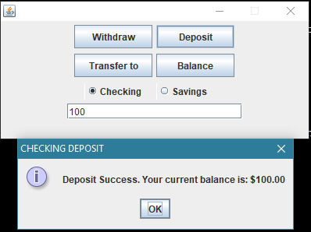

Checking deposit 100

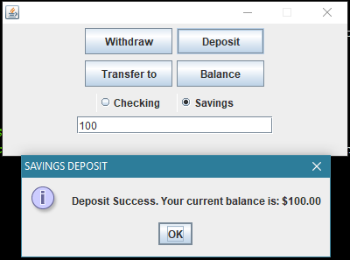

Savings deposit 100

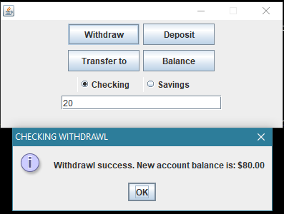

Checking withdraw 20

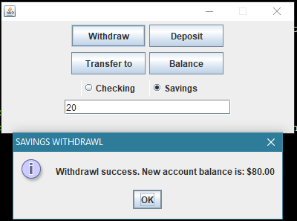

Checking withdraw 20

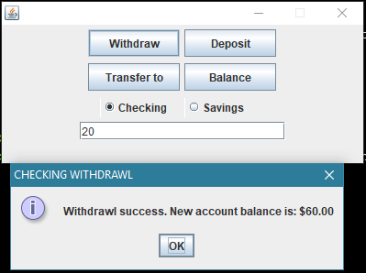

Checking withdraw 20

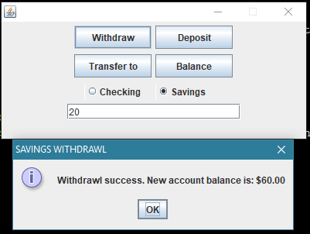

Checking withdraw 20

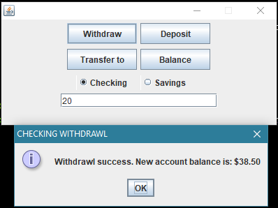

Checking withdraw 20 (fifth withdrawal; fee of 1.50 starts)

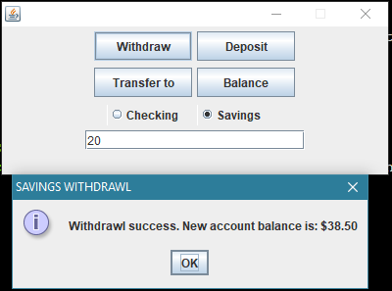

Savings withdraw 20 (sixth withdrawal; 1.50 fee assessed)

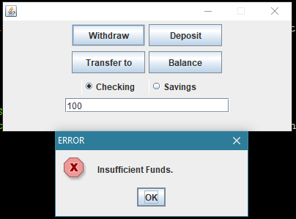

Attempted overdraft displays error message

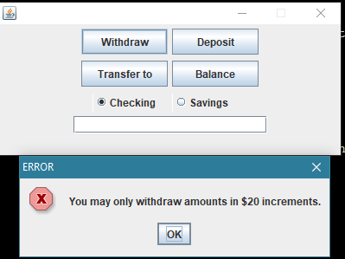

Null response displays error message

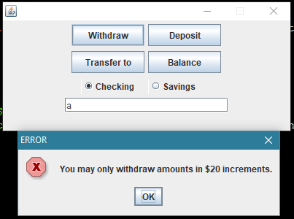

Non-integer input displays error message

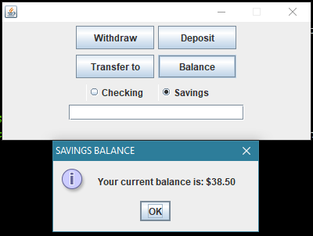

Balance check is correct

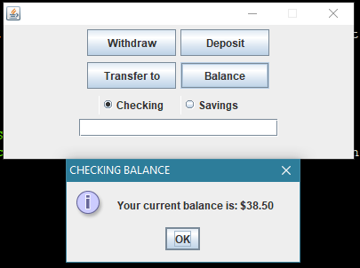

Balance check is correct

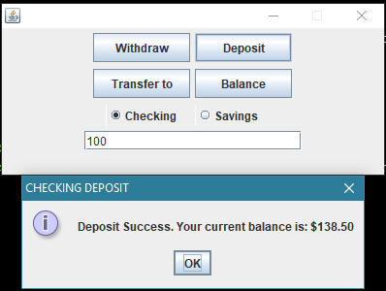

Depost 100 to checking and transfer to savings

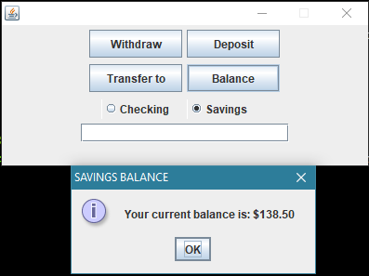

Savings balance after transfer

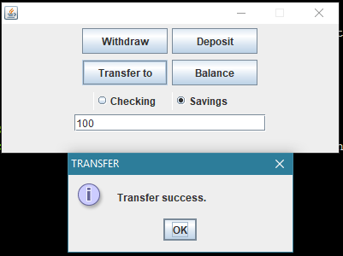

Transfer confirmation

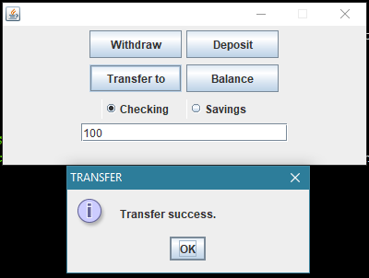

Transfer confirmation to transfer back to checking

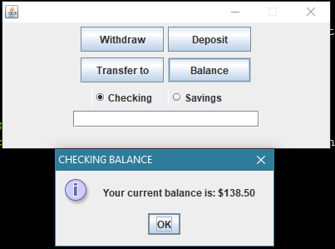

Checking balance after transfer

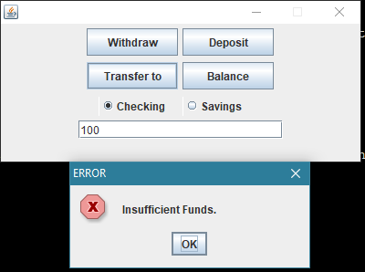

Attempt to transfer overdraft from savings

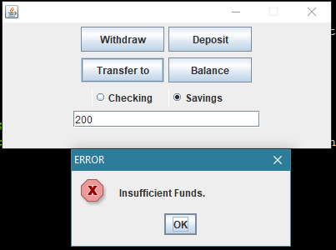

Attempt to transfer overdraft from checking